# Plan Scheduler

Create a Web page (HTML5 + CSS3 + images) that looks and behaves like the screenshot below:

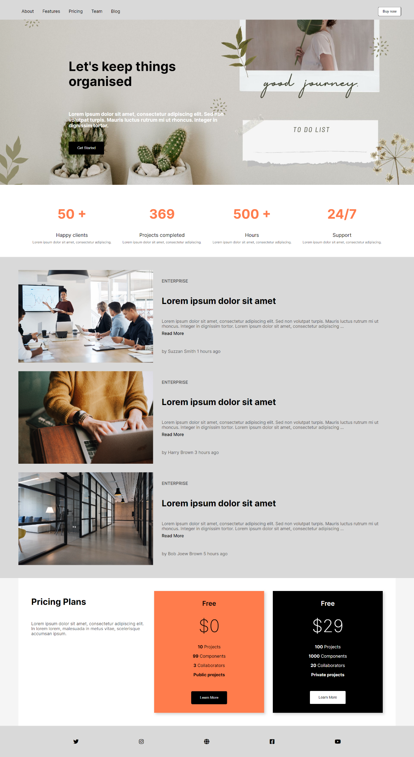

You are given the above screenshots + all required images.

### Output

The output should be valid **HTML5** + **CSS3** + **images** that implement the above web page.

### Constraints

* Use font – (<https://fonts.googleapis.com/css2?family=Inter:wght@100;200;300;400;500;600;700;800;900&amp;display=swap>)
* The site should open correctly in the **latest** version of **Chrome**